

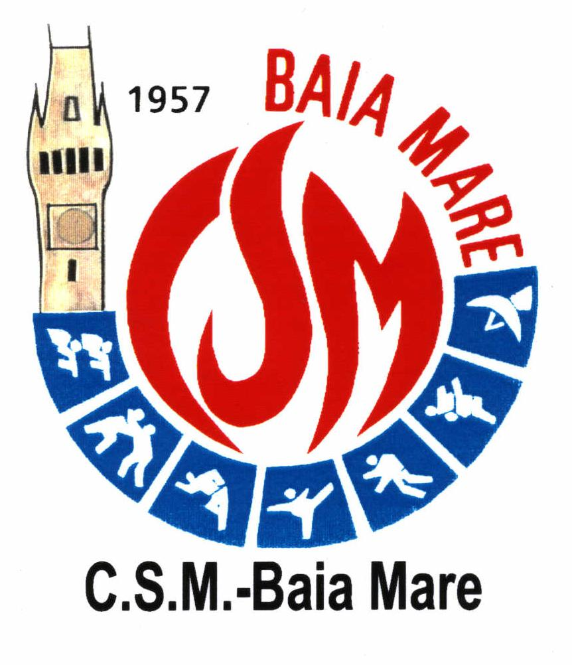
Agentia Nationala pentru Sport
CLUBUL SPORTIV MUNICIPAL
BAIA MARE
RO; 430272 Baia Mare; B-dul Unirii, nr. 14 A
Tel: + 40262 223790; Fax +40262 223777; e-mail: csmbaiamare@yahoo.com






DEAR FRIENDS,
WE HAVE THE PLEASURE TO INVITE YOU TO OUR COMPETITION, WHICH WILL TAKE PLACE ON THE 22-24 MAY 2009 IN BAIA MARE – ROMANIA.
THE INTERNATIONAL TOURNAMENT - JUDO
“THE NORTH CUP” – 6TH EDITION
BAIA MARE – ROMANIA
DATE | 22 – 24.05-2009
ORGANIZER | CSM BAIA MARE, DSJ MM, THE CITY COUNCIL OF BAIA MARE
PLACE | THE POLYVALENT HALL FROM BAIA MARE, 14A UNIRII ST.
AGE GROUPS | U-11 ( 99-200 ) M: 24,27,30,34,38,42,46, 50,+50  F: 23,26,29,32,36,40, 44,48,+48  U-13 ( 97-98 ) M: 27,30,34,38,42,46,50, 55, +55  F: 26,29,32,36,40,44, 48,52,+52  U-15 ( 95-96 ) M: 34,38,42,46,50,55,60, 66,+66  F: 32,36,40,44,48,52, 57,63,+63  U-17 ( 93-94 ) M: 46,50,55,60,66,73,81,90,+90  F: 40,44,48,52,57,63,70,+70  U-20+U-23+SEN M: 55,60,66,73,81,90,100,+100  > 94 F: 44,48,52,57,63,70,78,+78
COMPETITION SYSTEM | ACCORDING TO THE REGULATIONS OF U.E.J.  UP TO 6 FIGHTING FIELDS
UMPIRAGE | U.E.J. AND F.R.J. REGULATIONS
ENTRY FEE | 5 EURO / PERSON – EACH START
ACCOMODATION | “AMBASADOR” HOTEL **** - 15EUR/PERS/ZI  “MARA” HOTEL *** - 23EUR/PERS/ZI – BREAKFAST INCLUDED  PENSION – 11EUR/PERS/ZI
ENTRIES | BY MEANS OF THE ATTACHED FORM AT LEAST BY MAY 10TH, 2009  FAX: 004-0262223777  E-MAIL: vlad_judo01@yahoo.com
GUESTS | SPORTS PEOPLE FROM: HUNGARY, AUSTRIA, CROATIA, MOLDAVIA, GERMANY, SWITZERLAND, SERBIA, ITALY, BULGARY, POLAND, SLOVAKIA, ROMANIA
REWARDS | MEDALS AND DIPLOMAS FOR THE PLACES 1-3  FOR THE CLUB COMPETITION THE FOLLOWING POINTS WILL BE ASSIGNED AND THE RESULTS OF BOTH DAYS WILL BE ADDED TOGETHER.  1ST PLACE – 5PCT. 2ND PLACE – 3PCT. 3RD PLACE – 1PCT  FOR TEAM: 1ST PLACE – 500 EURO  2ND PLACE – 300 EURO  3RD PLACE – 200 EURO
CONTACT PERSON FOR FURTHER INFORMATION | ROMANIAN LANGUAGE: VASILE SALINCEAN – 0040-723969038  VASILE POP – 0040-748944411  ALIN POPDAN – 0040-749245108  HUNGARYAN LANGUAGE: ROBERT ALMASI – 0040-744784778  ENGLISH LANGUAGE: SORIN ANDREI – 0040-740008386
PROGRAM | FRIDAY 22.05-2009  8⁰⁰ – 18⁰⁰ – ARRIVAL OF DELEGATIONS AND OFFICIAL BALANCE  19³⁰ – TECHNICAL MEETING( DSJ HALL - 14A UNIRII ST )  SATURDAY 23.05-2009  9³⁰ – 18⁰⁰ – COMPETITIE U-11, U-13, U-15  SUNDAY 24,05-2009  9³⁰ – 18⁰⁰ – U-17, U-20+U-23+SENIORS


TABEL NOMINAL
INSCRIERE „CUPA NORDULUI”

NAME OF THE CLUB:______________________________________________
NATIONS:_____________________ COACH:___________________________
PHONE NUMBER:_____________________ E-MAIL:_____________________

 | NAME | W | M | WEIGHT CATEGORY | AGE GROPUS
 |  |  |  |  | U-11 | U-13 | U-15 | U-17 | SEN

